Link: <http://www.studytonight.com/operating-system/cpu-scheduling>

Add one more topic to the list of algorithms:

Given:

**Scheduling Algorithms**

We'll discuss four major scheduling algorithms here which are following :

1. First Come First Serve(FCFS) Scheduling
2. Shortest-Job-First(SJF) Scheduling
3. Priority Scheduling
4. Round Robin(RR) Scheduling
5. Multilevel Queue Scheduling

Add

**Scheduling Algorithms**

We'll discuss four major scheduling algorithms here which are following :

1. First Come First Serve(FCFS) Scheduling
2. Shortest-Job-First(SJF) Scheduling
3. Priority Scheduling
4. Round Robin(RR) Scheduling
5. Multilevel Queue Scheduling
6. **Multilevel feedback Queue Scheduling**

After the topic: Multilevel Queue Scheduling add this 6th method:

**Multilevel Feedback Queue Scheduling:**

Normally, in a multilevel queue-scheduling algorithm, processes are permanently assigned to a queue on entry to the system. Processes do not move between queues. This setup has the advantage of low scheduling overhead, but the disadvantage of being inflexible.

**Multilevel feedback queue scheduling**, however, allows a process to move between queues. The idea is to separate processes with different CPU-burst characteristics. If a process uses too much CPU time, it will be moved to a lower-priority queue. Similarly, a process that waits too long in a lower-priority queue may be moved to a higher-priority queue. This form of aging prevents starvation.

**An example of a multilevel feedback queue can be seen in the below figure:**

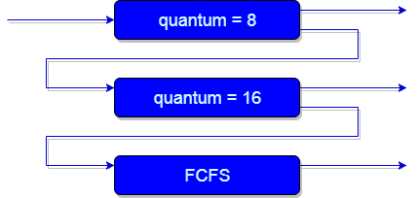

In general, a multilevel feedback queue scheduler is defined by the following parameters:

* The number of queues
* The scheduling algorithm for each queue
* The method used to determine when to upgrade a process to a higher-priority queue
* The method used to determine when to demote a process to a lower-priority queue
* The method used to determine which queue a process will enter when that process needs service

The definition of a multilevel feedback queue scheduler makes it the most general CPU-scheduling algorithm. It can be configured to match a specific system under design. Unfortunately, it also requires some means of selecting values for all the parameters to define the best scheduler. Although a multilevel feedback queue is the **most general scheme**, it is also the **most complex.**